LAB Assignment

Submitted by -
Name: Shah Alam Abir
Roll: BSSE-1439
E-mail: bsse1439@iit.du.ac.bd

Submitted to -
Name: Dr. Md. Shariful Islam
Professor, Institute of Information Technology, University of Dhaka
Email: shariful@iit.du.ac.bd

1. nslookup

Answers:
1. Run nslookup httpd.apache.org. IP Address of this server is 151.101.2.132

2. Run nslookup -type=NS cam.ac.uk to get all the authoritative servers of University of Cambridge. List of authoritative DNS servers of University of Cambridge is -
1. cam.ac.uk nameserver = ns3.mythic-beasts.com.
2. cam.ac.uk nameserver = ns2.ic.ac.uk.
3. cam.ac.uk nameserver = dns0.cl.cam.ac.uk.
4. cam.ac.uk nameserver = auth0.dns.cam.ac.uk.
5. cam.ac.uk nameserver = dns0.eng.cam.ac.uk.
6. cam.ac.uk nameserver = ns1.mythic-beasts.com.

3. There is no DNS server obtained in Question 2 that could queried for the mail server for Yahoo! Mail. Yahoo! Mail can be queried from these servers
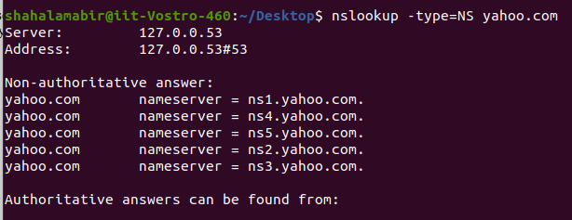
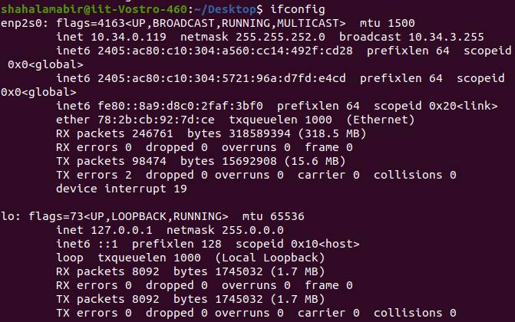
2. ifconfig

3. Tracing DNS with Wireshark

Answers:
4.
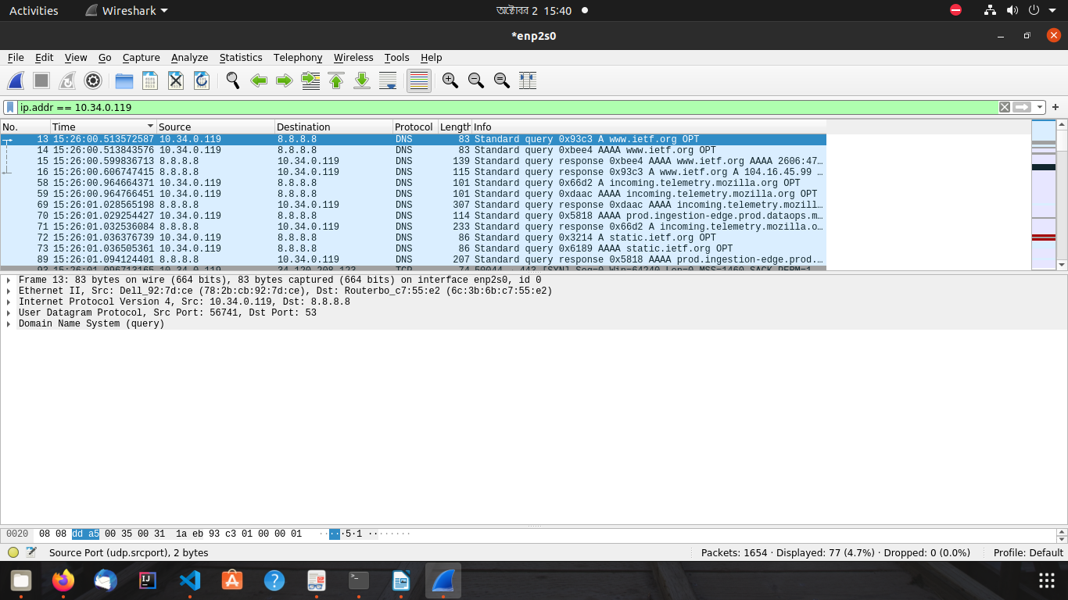
These query and responses were sent over UDP.

5. Destination port for DNS query message is 53. Source port for the DNS response message is 53.

6. DNS query message has sent to IP Address 8.8.8.8. IP Address of my local DNS server is also 8.8.8.8. Both of them are same

7. First DNS query is of type A. Second DNS query is of type AAAA. No, none of this two DNS query messages contains any “answers”.

8. There are two “answers” provided in both of the DNS response messages.

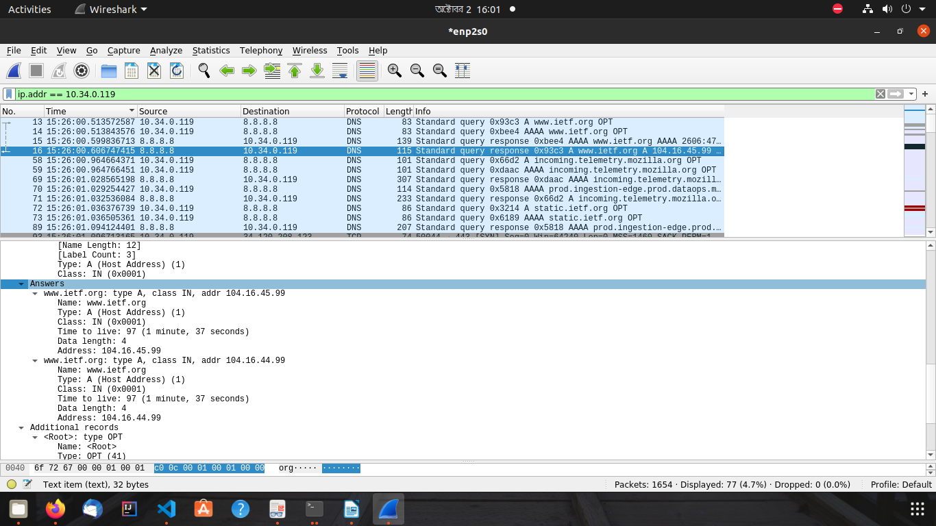
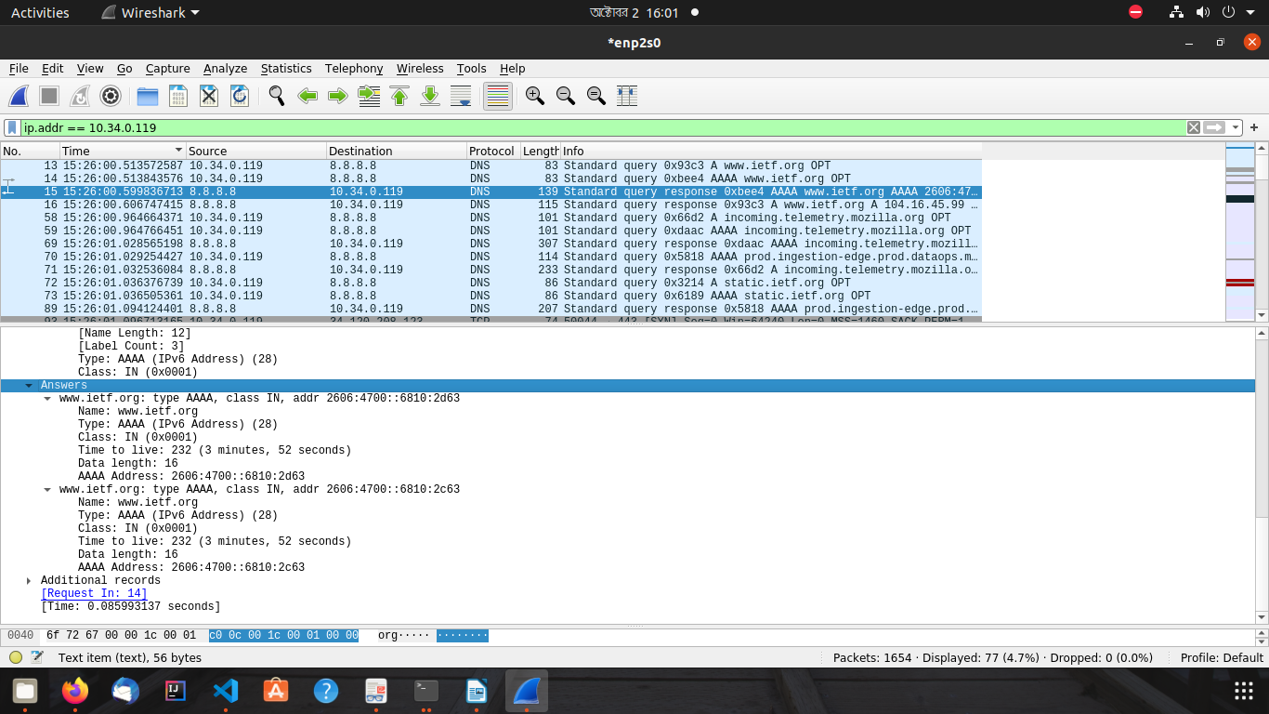

9. No, the destination IP address of the SYN packet doesn’t correspond to any of the IP addresses provided in the DNS response message.

10. No, there is only previous two DNS queries.

11. The destination port for the DNS query message is 53. The source port
of DNS response message 53.

12. DNS query message sent at IP Address 192.168.0.1. Yes, this is the IP Address of my default DNS server.

13. This is ‘A’ type DNS query. No, the query message doesn’t contains any “answers”.

14. There are 3 answers provided into the DNS query response message. Answers contains

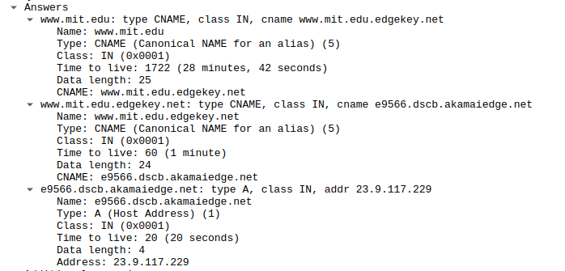

15.
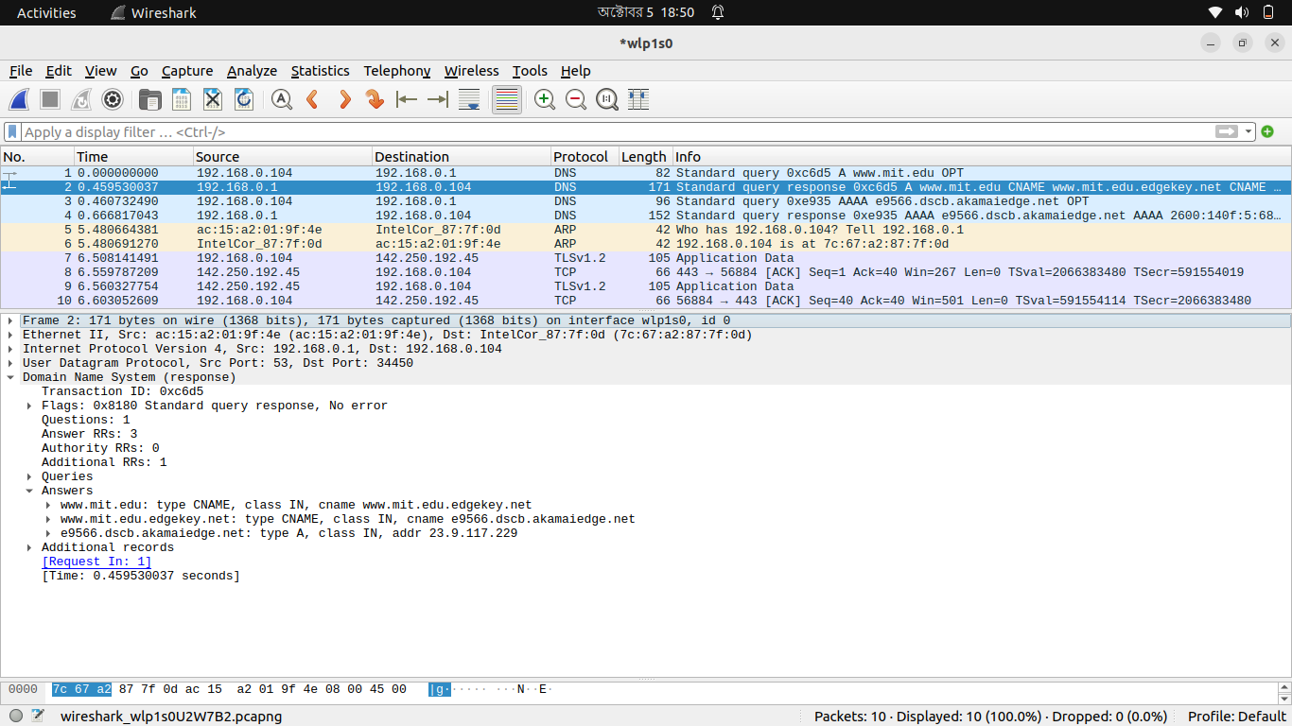
16. DNS query message sent at IP Address 192.168.0.1. Yes, this is the IP Address of my default DNS server.

17. This is ‘NS’ type DNS query. No, the query message doesn’t contains any “answers”.

18. The response message provides 8 MIT nameservers name. These are -

mit.edu: type NS, class IN, ns ns1-37.akam.net
mit.edu: type NS, class IN, ns asia1.akam.net
mit.edu: type NS, class IN, ns use5.akam.net
mit.edu: type NS, class IN, ns eur5.akam.net
mit.edu: type NS, class IN, ns usw2.akam.net
mit.edu: type NS, class IN, ns use2.akam.net
mit.edu: type NS, class IN, ns ns1-173.akam.net
mit.edu: type NS, class IN, ns asia2.akam.net

No, this response message doesn’t provides the IP addresses of the MIT nameservers.

19.
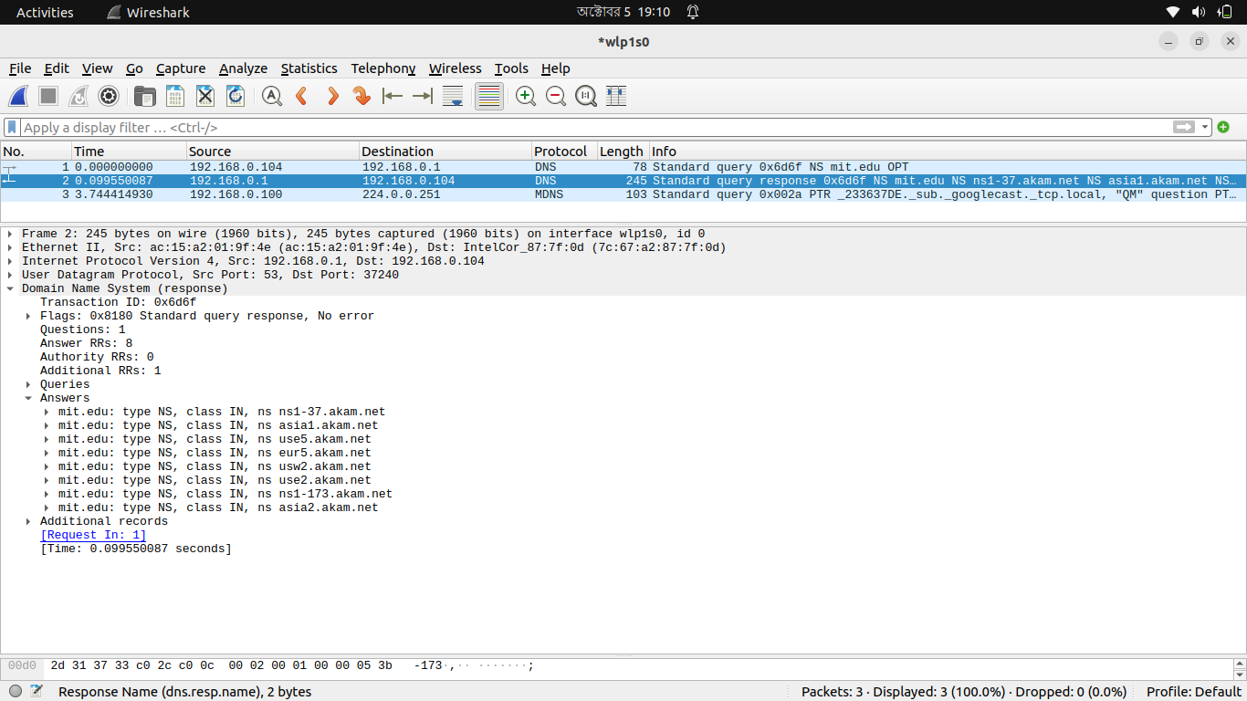

20. DNS query message has been sent to 193.108.91.37. No, This is not the IP address of my default local DNS server. This ip address corresponds to the IP Address of the nameserver of mit.edu which is “ns1-37.akam.net”.
21. Type of the DNS query message is ‘A’. No, this query message doesn’t contains any answer.

22. There is only 1 answer is provided into the DNS response message. This contains -

23.

